Danube Hack 2016, Bratislava, December 12-13

Idea pitch

Name of app: TBD

**Need and justification:**

Under the project DRDSI, there is Study on Citizen Science activities in the Danube Region. The goal is to determine whether there are data gaps, and which Citizen Science activities can close the gap. So far, the current phase of study completeness indicates that there is lack of data on bioenergy. This is fact across the Danube Region. There are also not much Citizen Science activities dealing with this kind of data.

Therefore, there is a need to start an activity to collect data for this category, bioenergy.

**Model to resolve the issue:**

Since the Agriculture has long been a major source of income for many people living in the Danube Region, it can be concluded that there is a lot of vineyards and orchards. The common agriculture rule is that these vineyards and orchards need to be pruned twice a year. Usually, the owners are doing this on the way that they collect all the branches on one pile after the pruning, and then burn this pile.

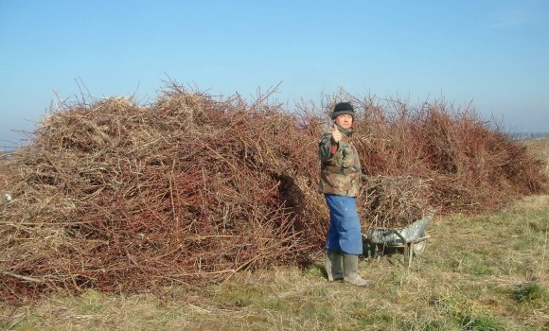

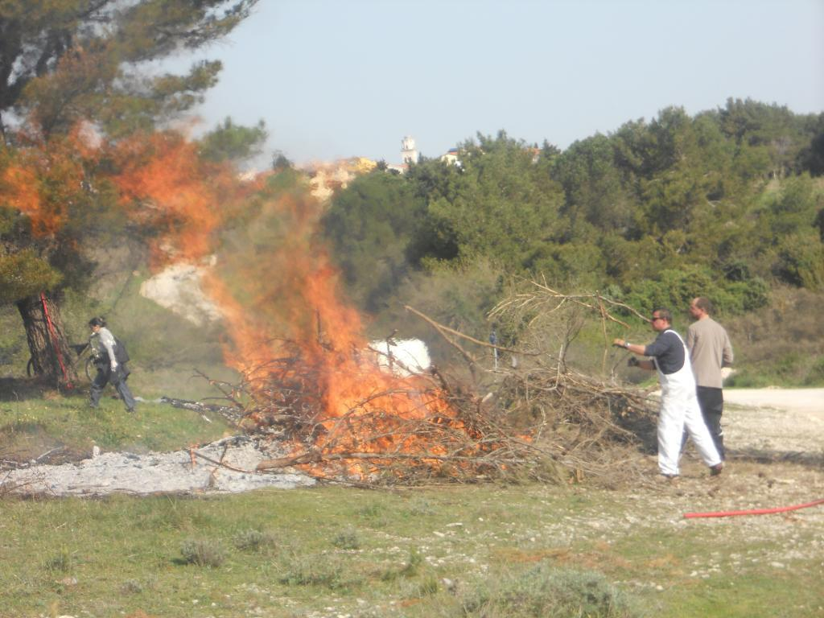

But, the fact is that those branches are raw material for production of wood pellets, e. g. biomass for heating.

So, what if owner of the orchard could photograph the pile of branches which he collected, and to save it's location (GPS coordinates of the smartphone that he used to take the photo)? These data would be useful to wood pellets producers in order to come to the location and pick up the branches for their production.

The app that enables this should be developed for two sides – owners of vineyards or orchards, and biomass producers. It should have functionality to collect the point location of the pile (using GPS location) and photo of the pile, and maybe one more attribute about estimation of quantity or volume of the branch pile.

**Benefits of the app and other issues resolved with the app:**

* Security is increased since there is less burning outdoors without controlled conditions
* The owners have less work since they don't need to organize burning activities, so it is easier for them to maintain the orchard or vineyard
* Environment protection – less pollution of atmosphere from combustion
* Environment protection – less healthy trees need to be cut down in order to acquire raw material for biomass
* Energy production – more biomass for production of energy resources
* Science – one more spatial dataset on bioenergy material